QUANTUM NUMBERS

QUANTUM

a very small quantity of electromagnetic energy.

Quantum numbers are the set of numbers used to describe the position and energy of an electron in an atom.

TYPES

**the principal quantum number (n), the orbital angular momentum quantum number (l), the magnetic quantum number (ml), and the electron spin quantum number (ms)**.

principal quantum number

* ***Principal quantum numbers are denoted by the symbol ‘n’. They designate the principal electron shell of the atom.*** Since the most probable distance between the nucleus and the electrons is described by it, a larger value of the principal quantum number implies a greater distance between the electron and the nucleus (which, in turn, implies a greater atomic size).
* The value of the principal quantum number can be any integer with a positive value that is equal to or greater than one. The value n=1 denotes the innermost electron shell of an atom, which corresponds to the lowest [energy state](https://byjus.com/physics/energy-level/) (or the ground state) of an electron.
* Thus, it can be understood that the principal quantum number, n, cannot have a negative value or be equal to zero because it is not possible for an atom to have a negative value or no value for a principal shell.
* When a given electron is infused with energy (excited state), it can be observed that the electron jumps from one principle shell to a higher shell, causing an increase in the value of n. Similarly, when electrons lose energy, they jump back into lower shells and the value of n also decreases.
* The increase in the value of n for an electron is called absorption, emphasizing the photons or energy being absorbed by the electron. Similarly, the decrease in the value of n for an electron is called emission, where the electrons emit their energy.

Azimuthal Quantum Number (Orbital Angular Momentum Quantum Number)

* The azimuthal (or orbital angular momentum) quantum number describes the shape of a given orbital. It is denoted by the symbol ‘l’ and its value is equal to the total number of angular nodes in the orbital.
* A value of the [azimuthal quantum number](https://byjus.com/physics/azimuthal-quantum-number/) can indicate either an s, p, d, or f subshell which vary in shape. This value depends on (and is capped by) the value of the principal quantum number, i.e. the value of the azimuthal quantum number ranges between 0 and (n-1).
* For example, if n =3, the azimuthal quantum number can take on the following values – 0,1, and 2. When l=0, the resulting subshell is an ‘s’ subshell. Similarly, when l=1 and l=2, the resulting subshells are ‘p’ and ‘d’ subshells (respectively). Therefore, when n=3, the three possible subshells are 3s, 3p, and 3d.
* In another example where the value of n is 5, the possible values of l are 0, 1, 2, 3, and 4. If l = 3, then there are a total of three angular nodes in the atom.

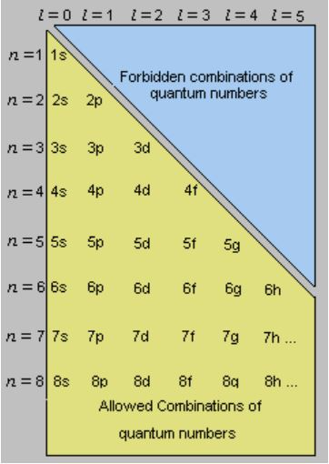

Magnetic Quantum Number

The total number of orbitals in a subshell and the orientation of these orbitals are determined by the magnetic quantum number. It is denoted by the symbol ‘ml’. This number yields the projection of the angular momentum corresponding to the orbital along a given axis.

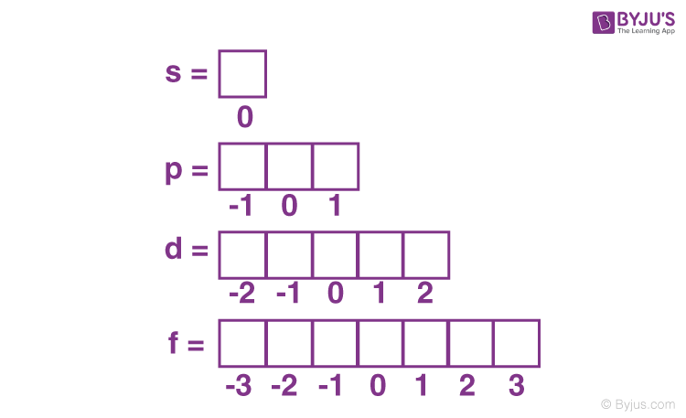

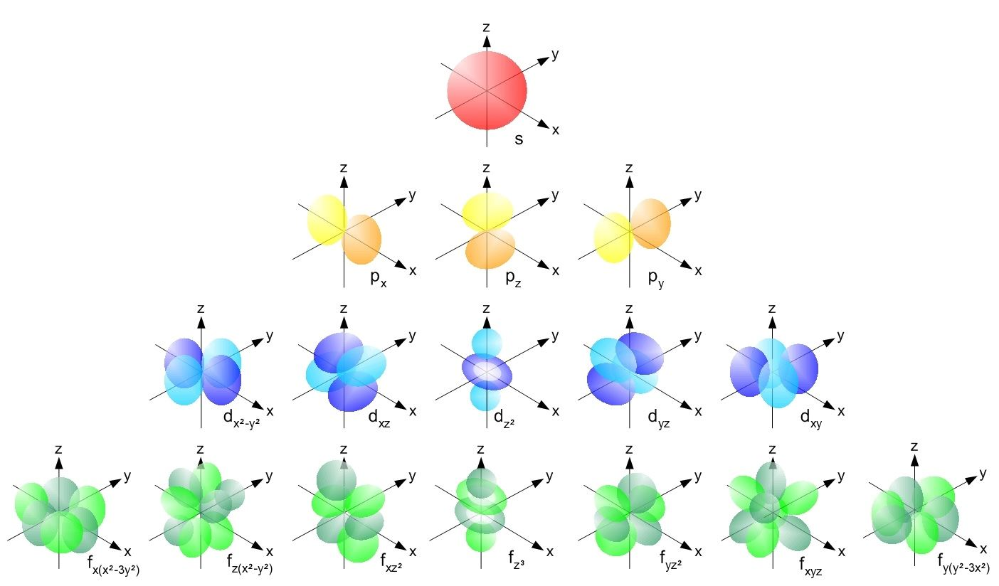

Shapes of Orbitals (as per the corresponding Quantum Numbers)

The value of the [magnetic quantum number](https://byjus.com/physics/magnetic-quantum-number/) is dependent on the value of the azimuthal (or orbital angular momentum) quantum number. For a given value of l, the value of ml ranges between the interval -l to +l. Therefore, it indirectly depends on the value of n.

For example, if n = 4 and l = 3 in an atom, the possible values of the magnetic quantum number are -3, -2, -1, 0, +1, +2, and +3.

|  |  |  |
| --- | --- | --- |
| Azimuthal Quantum Number Value | Corresponding Number of Orbitals (2l + 1) | Possible Values of ml |
| 0 (‘s’ subshell) | 2*0 + 1 = 1 | 0 |
| 1 (‘p’ subshell) | 2*1 + 1 = 3 | -1, 0, and 1 |
| 2 (‘d’ subshell) | 2*2 + 1 = 5 | -2, -1, 0, 1, and 2 |
| 3 (‘f’ subshell) | 2*3 + 1 = 7 | -3, -2, -1, 0, 1, 2, and 3 |

The total number of orbitals in a given subshell is a function of the ‘l’ value of that orbital. It is given by the formula (2l + 1). For example, the ‘3d’ subshell (n=3, l=2) contains 5 orbitals (2*2 + 1). Each orbital can accommodate 2 electrons. Therefore, the 3d subshell can hold a total of 10 electrons.

Electron Spin Quantum Number

* The electron[spin quantum number](https://byjus.com/chemistry/spin-quantum-number/) is independent of the values of n, l, and ml. The value of this number gives insight into the direction in which the electron is spinning, and is denoted by the symbol ms.
* The value of ms offers insight into the direction in which the electron is spinning. The possible values of the electron spin quantum number are +½ and -½.
* The positive value of ms implies an upward spin on the electron which is also called ‘spin up’ and is denoted by the symbol ↑. If ms has a negative value, the electron in question is said to have a downward spin, or a ‘spin down’, which is given by the symbol ↓.
* The value of the electron spin quantum number determines whether the atom in question has the ability to produce a magnetic field. The value of ms can be generalized to ±½.

